**CHATBOT DEPLOYMENT WITH IBM CLOUD WATSON ASSISTANT-BUILD A PROJECT**

|  |  |
| --- | --- |
| **Date** | **31-10-2023** |
| **Team ID** | **676** |
| **Project Name** | **Chatbot Deployment with IBM Watson Assistant** |

**Table of Contents**

|  |  |
| --- | --- |
| 1 | Introduction |
| 2 | Problem Statement |
| 3 | Starting Integration with Facebook Messenger |
| 3.1 | Add Facebook Messenger |
| 3.2 | Create a Facebook Application |
| 3.3 | Connect to Facebook Page |
| 3.4 | Connect to Facebook Webhooks |
| 3.5 | Connect To Assistant |

|  |  |
| --- | --- |
| 3.6 | App Review |
| 4 | Conclusion |

**1. Introduction**

In today's fast-faced digital world, businesses and organizations are constantly seeking innovative ways to engage with their audience, provide quick access to information, and enhance customer experiences. One such solution is the creation of a helpful virtual guide using IBM Cloud Watson Assistant. This virtual guide can be customized to assist users on popular messaging platforms like Facebook Messenger and Slack, offering a friendly and informative conversational experience.

**2. Problem Statement**

Create a helpful virtual guide using IBM Cloud Watson Assistant. Customize the chatbot to assist users on popular messaging platforms like Facebook Messenger and Slack. Provide useful information, answer FAQs, and offer a friendly conversational experience. Empower users with quick access to information and create meaningful connections through your virtual guide.

**3. Starting Integration with Facebook Messenger:**

To integrate IBM Watson Assistant with Facebook Messenger, first create a Facebook Developer account and a Facebook App. Obtain the necessary credentials, including an App Secret and Page Access Token, from your Facebook App settings. Access your IBM Watson Assistant instance and configure a specific skill for your Messenger chatbot. Within the Watson Assistant interface, navigate to the "Integrations" or "Channels" section and select Facebook Messenger as the integration channel. Complete the integration by providing the Page Access Token and customizing settings, then deploy your chatbot to Facebook Messenger for user engagement.

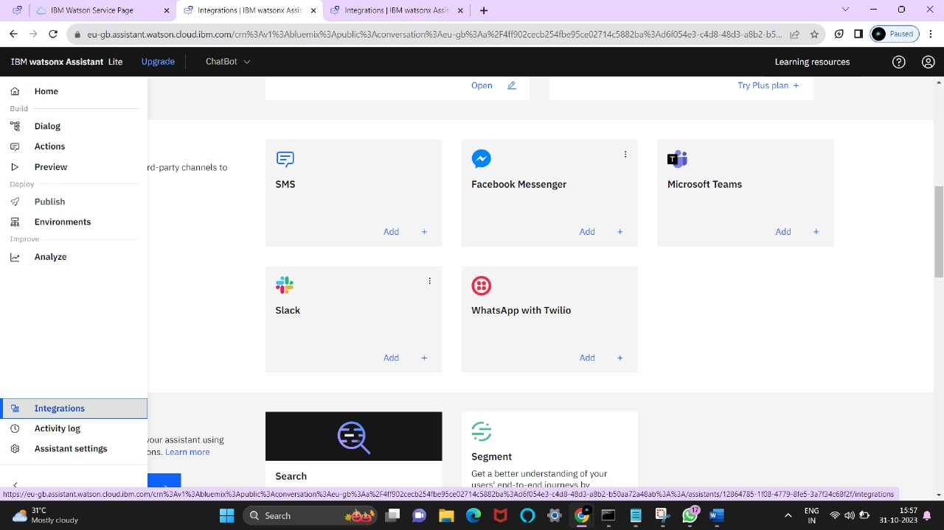

**3.1. Add Facebook Messenger:**

Through Facebook Messenger, your assistant is ready to join one of the best places to communicate with all the people and businesses in the world.

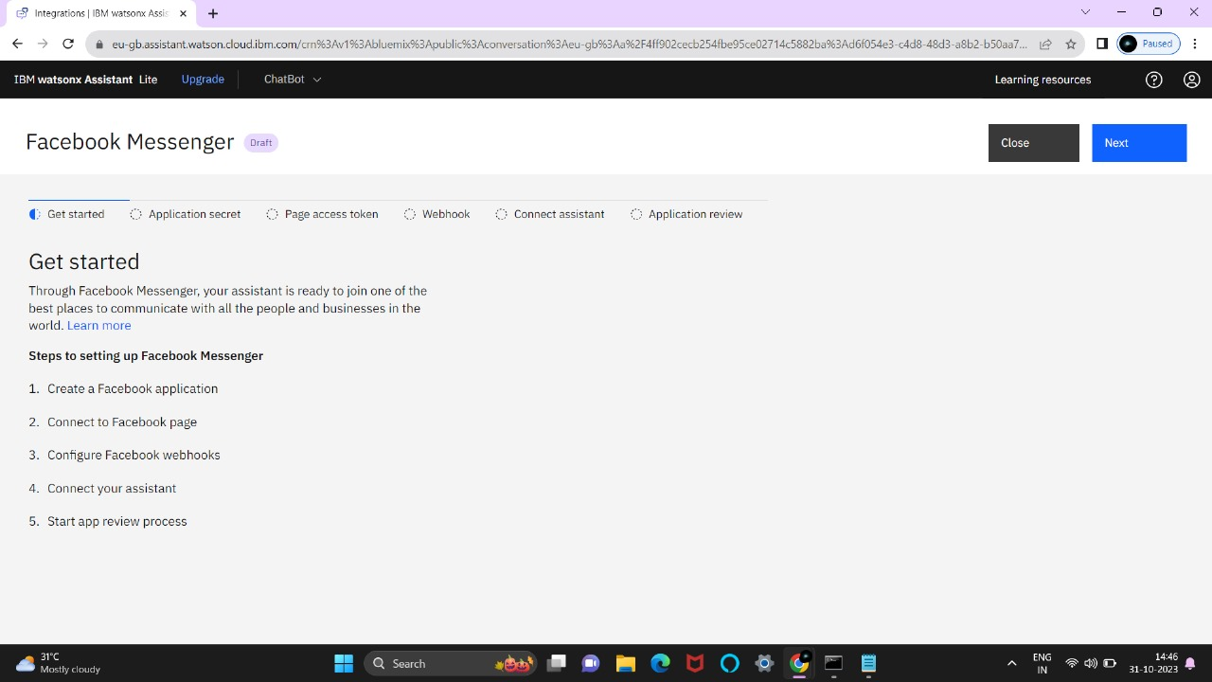

**3.2.Create a Facebbok Application:**

Go to [Facebook for Developers](https://developers.facebook.com/) and log in with your Facebook credentials. Click **Add a New App** and complete the steps to create a new app ID.

In the navigation pane, click **Settings -> Basic**. Under **App Secret**, click **Show**.

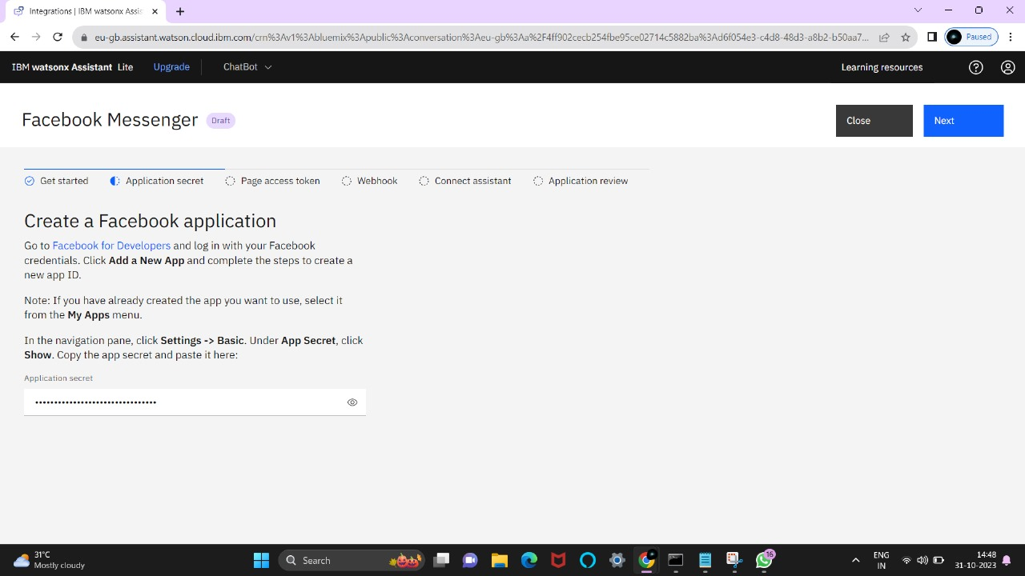

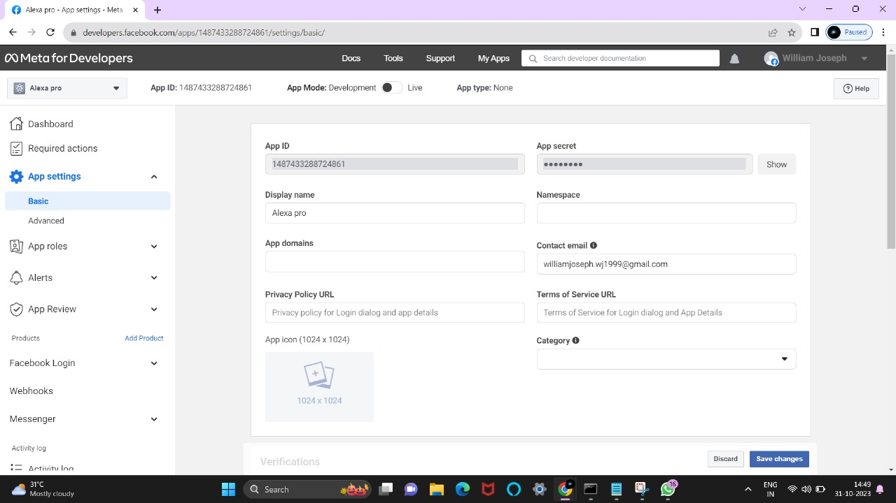

**3.3. Connect to Facebook Page:**

On the Facebook app page, click the plus sign (**+**) next to **Products** in the left side navigation. Under **Add a product**, find the **Messenger** tile and click **Set Up**. In the Messenger settings, scroll down to **Access Tokens**. Click **Add or Remove Pages** and choose the Facebook page you want to use for your app.Click **Generate Token** and check the **I Understand** checkbox to generate the page access token.

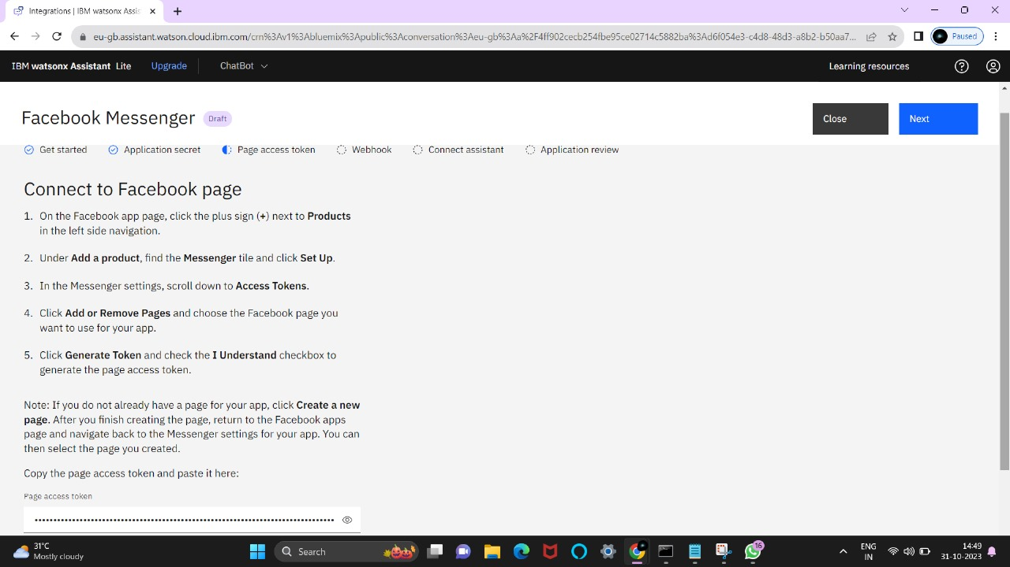

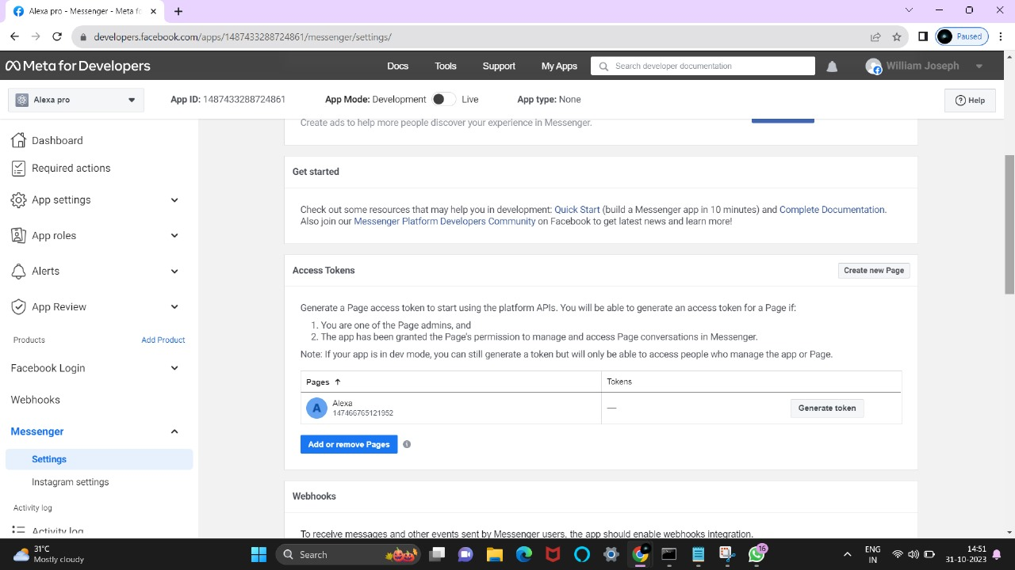

**3.4. Connect To Facebook Webhooks:**

In the Facebook Messenger settings, scroll to the **Webhooks** section. Click **Setup Webhooks**. In the **Edit Callback URL** window, paste the generated callback URL into the **Callback URL** field. In the **Verify Token** field, paste the verify token that was generated for you earlier. Click **Verify and Save**. Click **Add Subscriptions**. In the **Edit Page Subscriptions** window under **Subscription Fields**, select **messages** and **messaging_postbacks.** Click **Save**

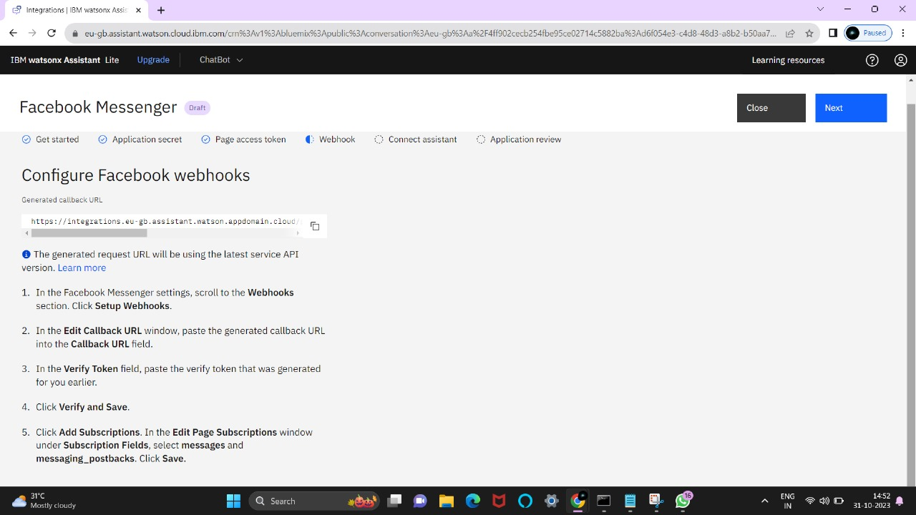

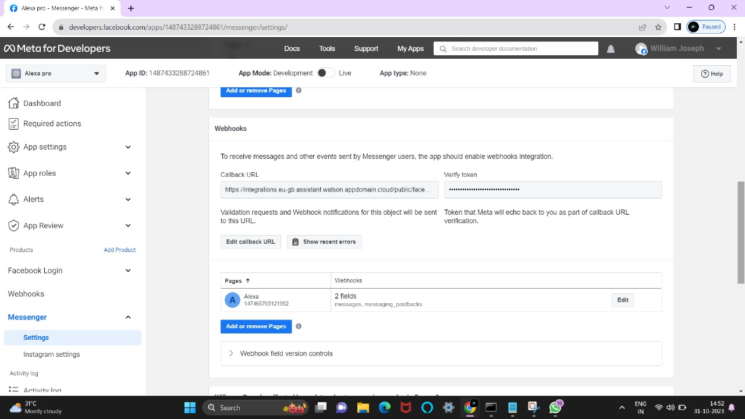

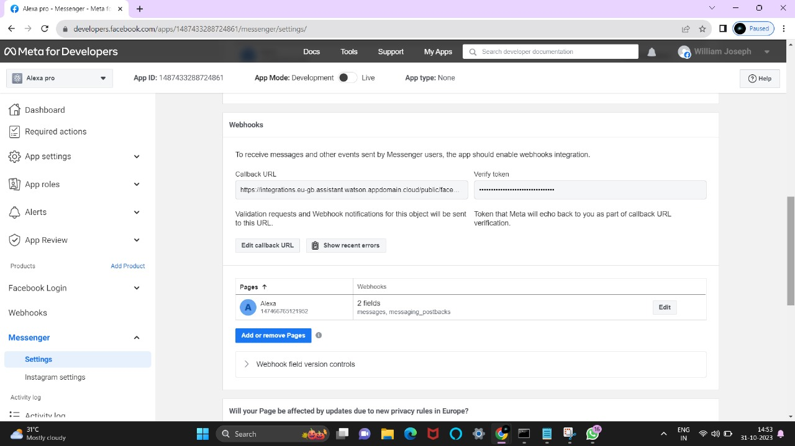

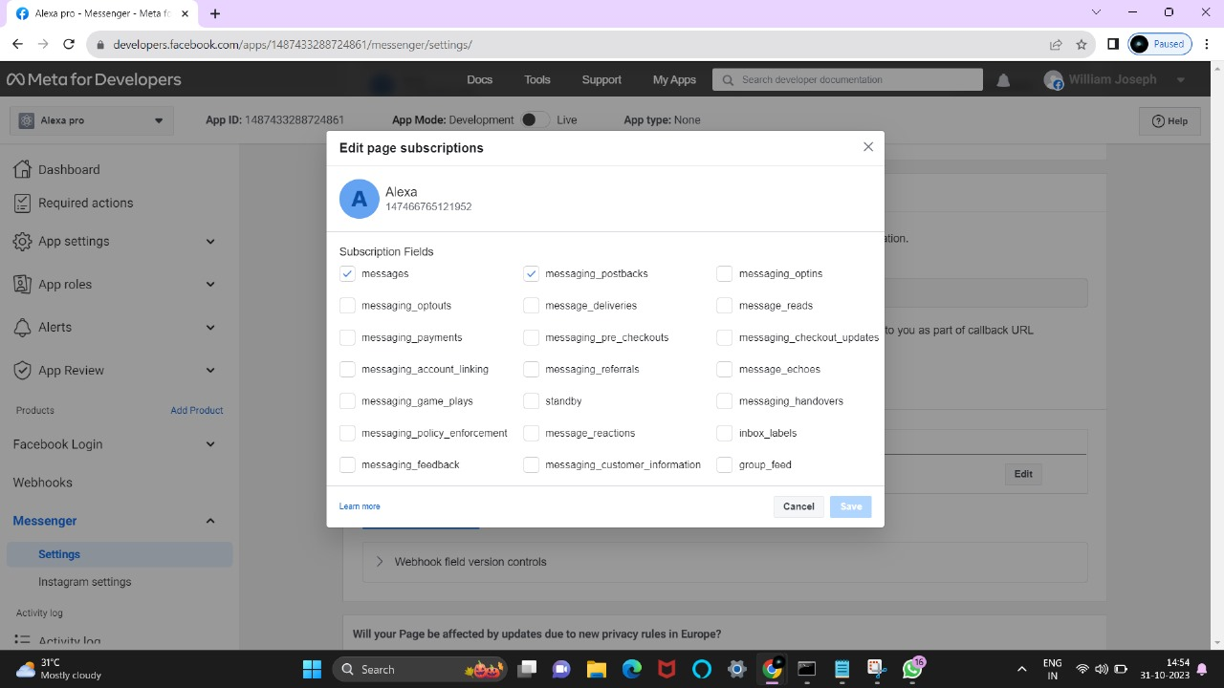

**3.5 Connect to Assistant:**

 You should be able to test your bot now in Messenger. You must be a Page admin to interact with it until you make it public.

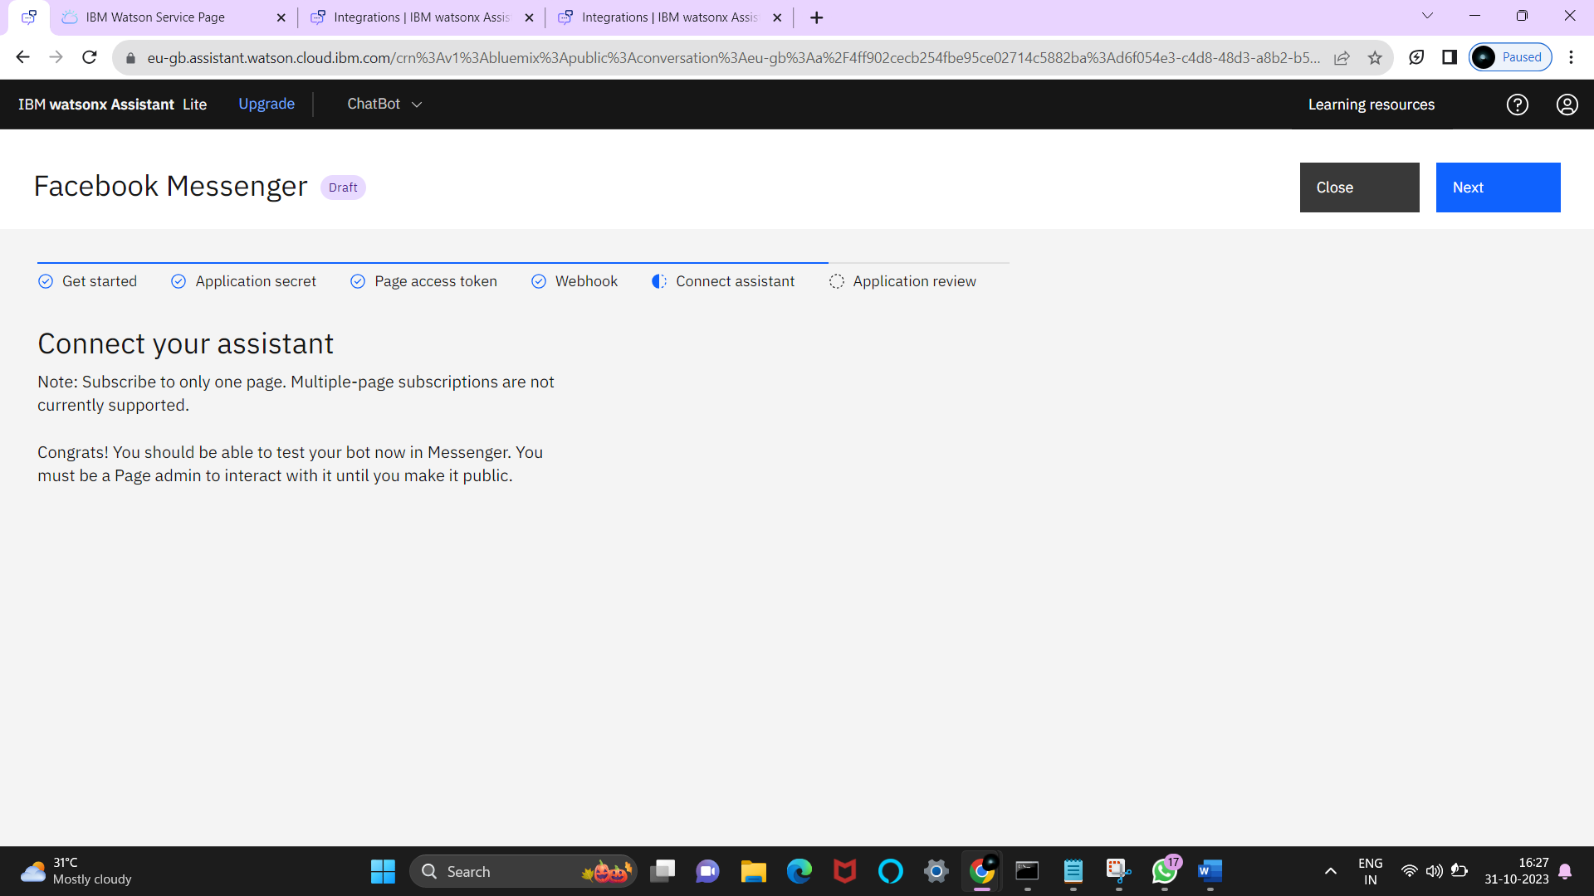

**3.6 App Review:**

Messenger App on Facebook for Developer's site and follow the instructions to start the app review process.

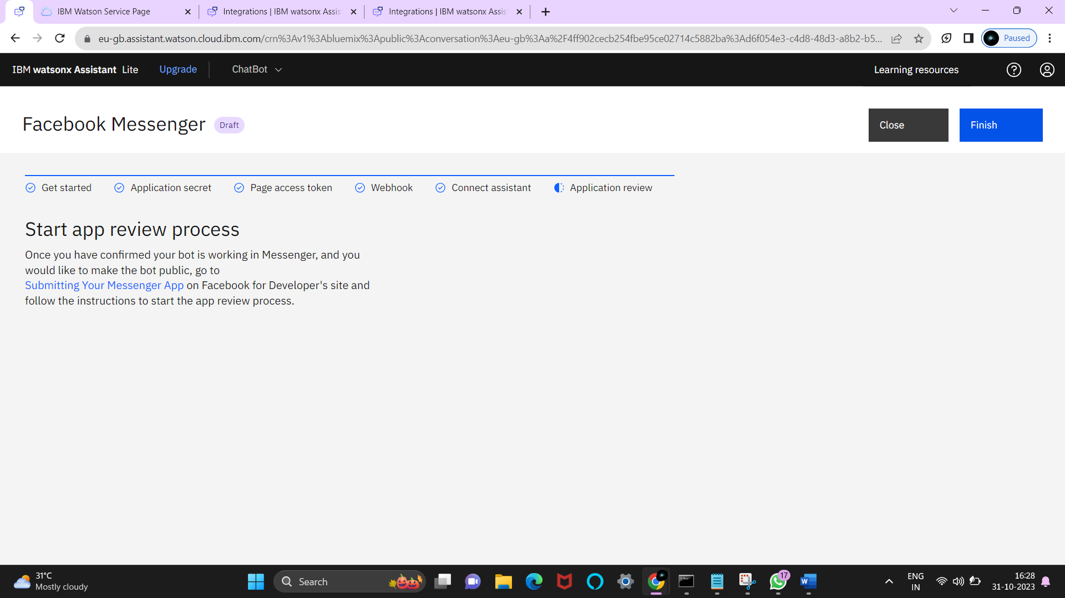

**4. Conclusion**

In conclusion, deploying a chatbot using IBM Cloud and integrating it with Watson Assistant offers a powerful and flexible solution for a wide range of project requirements. IBM Cloud Foundry provides a robust platform for hosting applications, ensuring scalability, security, and reliability. Watson Assistant, on the other hand, empowers the chatbot with natural language understanding capabilities, allowing it to interact with users effectively .This combination allows you to create a chatbot that can serve various functions, whether it's customer support, information retrieval, or process automation. Once you have performed the relevant activities and configured the chatbot, you can create a comprehensive document summarizing the project's architecture, deployment, and capabilities. This document will be invaluable for assessment, showcasing how IBM Cloud and Watson Assistant were leveraged to build a chatbot that meets the project's specific requirements effectively.And you must be able to test your bot now in Messenger.